1. Let’s take a look at the history of AWS Cloud.
2. In **2002**, it was first launched **internally at amazon.com** as they realised the requirement of externalizing IT Department.
3. But later on, they realized that they could do IT for others in **2003** (**Just an idea**)
4. So, they launched their **first offering publicly** which was **SQS in 2004**.
5. **In 2006,** they expanded their offering and relaunched with the availability of **SQS, S3 & EC2**.
6. Then, **in 2007** they expanded and said, “You know what! we don’t have to be just in **America**, we could be in **Europe**.”.
7. And then fast forward to today, we have so many apps that used to run on AWS or are still running on AWS.  
   Such as: **Dropbox, Netflix, Airbnb and even the NASA**.
8. Timeline

   Description automatically generated
9. **Now let’s have a look at where AWS is today**.
   1. If we look at the **Gartner Magic Quadrants,** which is sort of ranks the cloud providers, we can see AWS is on the top right corner which is a leader.
   2. Top Right means
      1. It is able to execute very well (Y-Axis = “Ability To Execute”).
      2. It has a really great completeness of vision (X-Axis = “Completeness of Vision”)
   3. 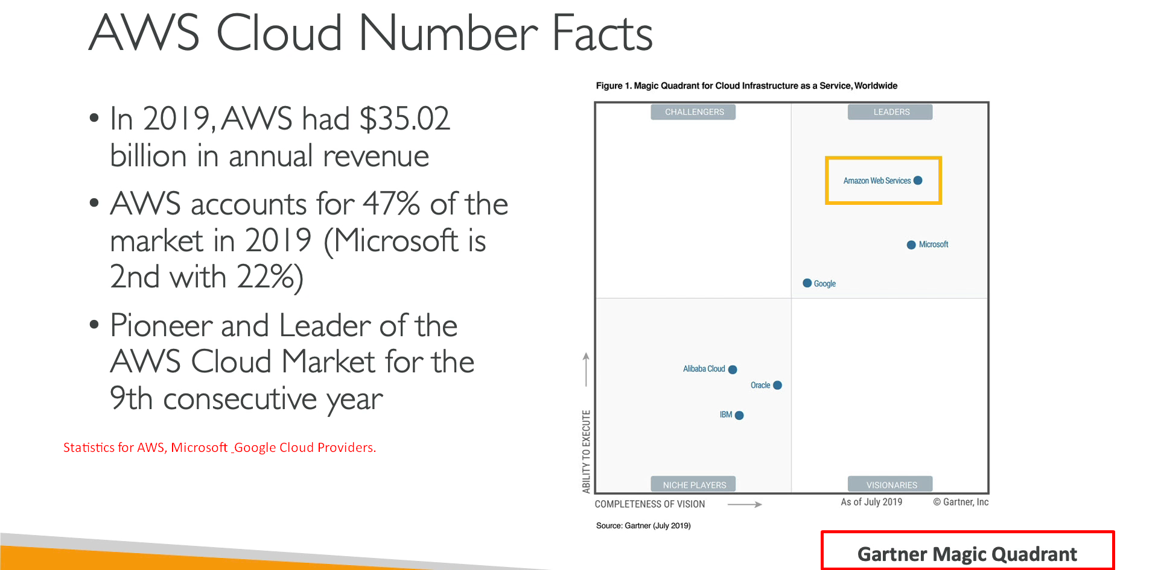
10. **So, what you can build on AWS?**
    1. Pretty much everything.
    2. AWS will enable you to build **sophisticated and scalable apps**.
    3. AWS is applicable to diverse set of industries.
    4. Every Company has a use-case for the cloud.
    5. **Use cases can include:**
       1. Enterprise IT.
       2. Using Cloud as Backup & Storage.
       3. or doing some big Data Analytics.
       4. Hosting a web site.
       5. Creating a backend for Mobile or social apps.
       6. Your entire gaming server running on cloud.
       7. The use cases are endless.
    6. Text

       Description automatically generated
11. **AWS Global Infrastructure.**
    1. AWS is global now.
    2. 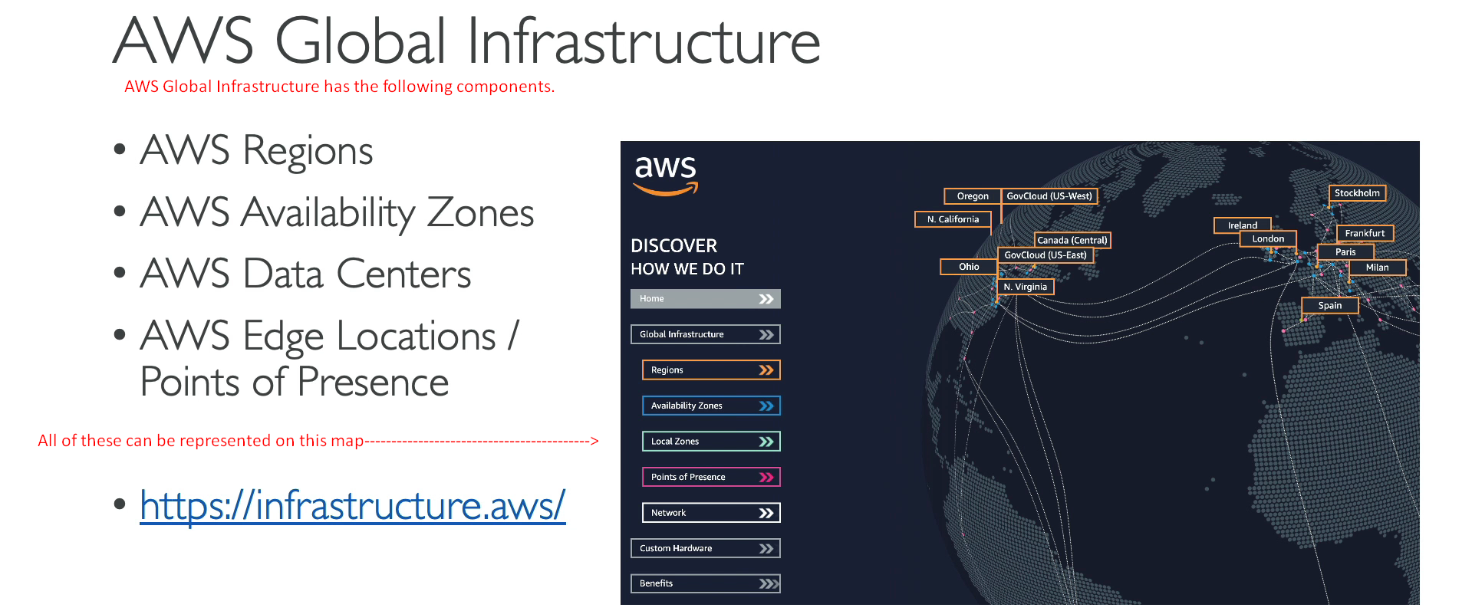
    3. 
    4. On this site, we can see how AWS is global. 😊
    5. **Regions in orange**:
       1. AWS has multiple regions around the world.
       2. 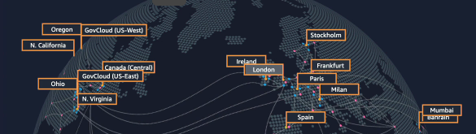
       3. See, those regions are connected by private network by AWS.
    6. **Availability Zones**:
       1. A picture containing shape

          Description automatically generated

So basically we can leverage the infrastructure of Cloud Provider to make our app global.

1. The first important concept in AWS is Region.
2. **Region**: